ITA0601 – MACHINE LEARNING
LAB EXPERIMENTS
EXP-14: House Price Prediction
Dataset 1 – House Price Prediction
Area (sq.ft) | Bedrooms | Bathrooms | Age (Years) | Price (Lakhs)
800 | 2 | 1 | 15 | 35
1000 | 2 | 2 | 12 | 45
1200 | 3 | 2 | 10 | 55
1400 | 3 | 2 | 8 | 65
1600 | 3 | 3 | 6 | 75
1800 | 4 | 3 | 5 | 85
2000 | 4 | 3 | 4 | 95
2200 | 4 | 4 | 3 | 110
2400 | 5 | 4 | 2 | 125
2600 | 5 | 4 | 1 | 140

Python Code:
import pandas as pd
from sklearn.linear_model import LinearRegression
data = {
"Area": [800, 1000, 1200, 1400, 1600,
1800, 2000, 2200, 2400, 2600],
"Bedrooms": [2, 2, 3, 3, 3, 4, 4, 4, 5, 5],
"Bathrooms": [1, 2, 2, 2, 3, 3, 3, 4, 4, 4],
"Age": [15, 12, 10, 8, 6, 5, 4, 3, 2, 1],
"Price": [35, 45, 55, 65, 75,
85, 95, 110, 125, 140]
}
df = pd.DataFrame(data)
X = df[["Area", "Bedrooms", "Bathrooms", "Age"]]
y = df["Price"]
model = LinearRegression()
model.fit(X, y)
new_house = pd.DataFrame({
"Area": [2000],
"Bedrooms": [4],
"Bathrooms": [3],
"Age": [4]
})
prediction = model.predict(new_house)
print("Predicted House Price:",
round(prediction[0], 2), "Lakhs")
Output:
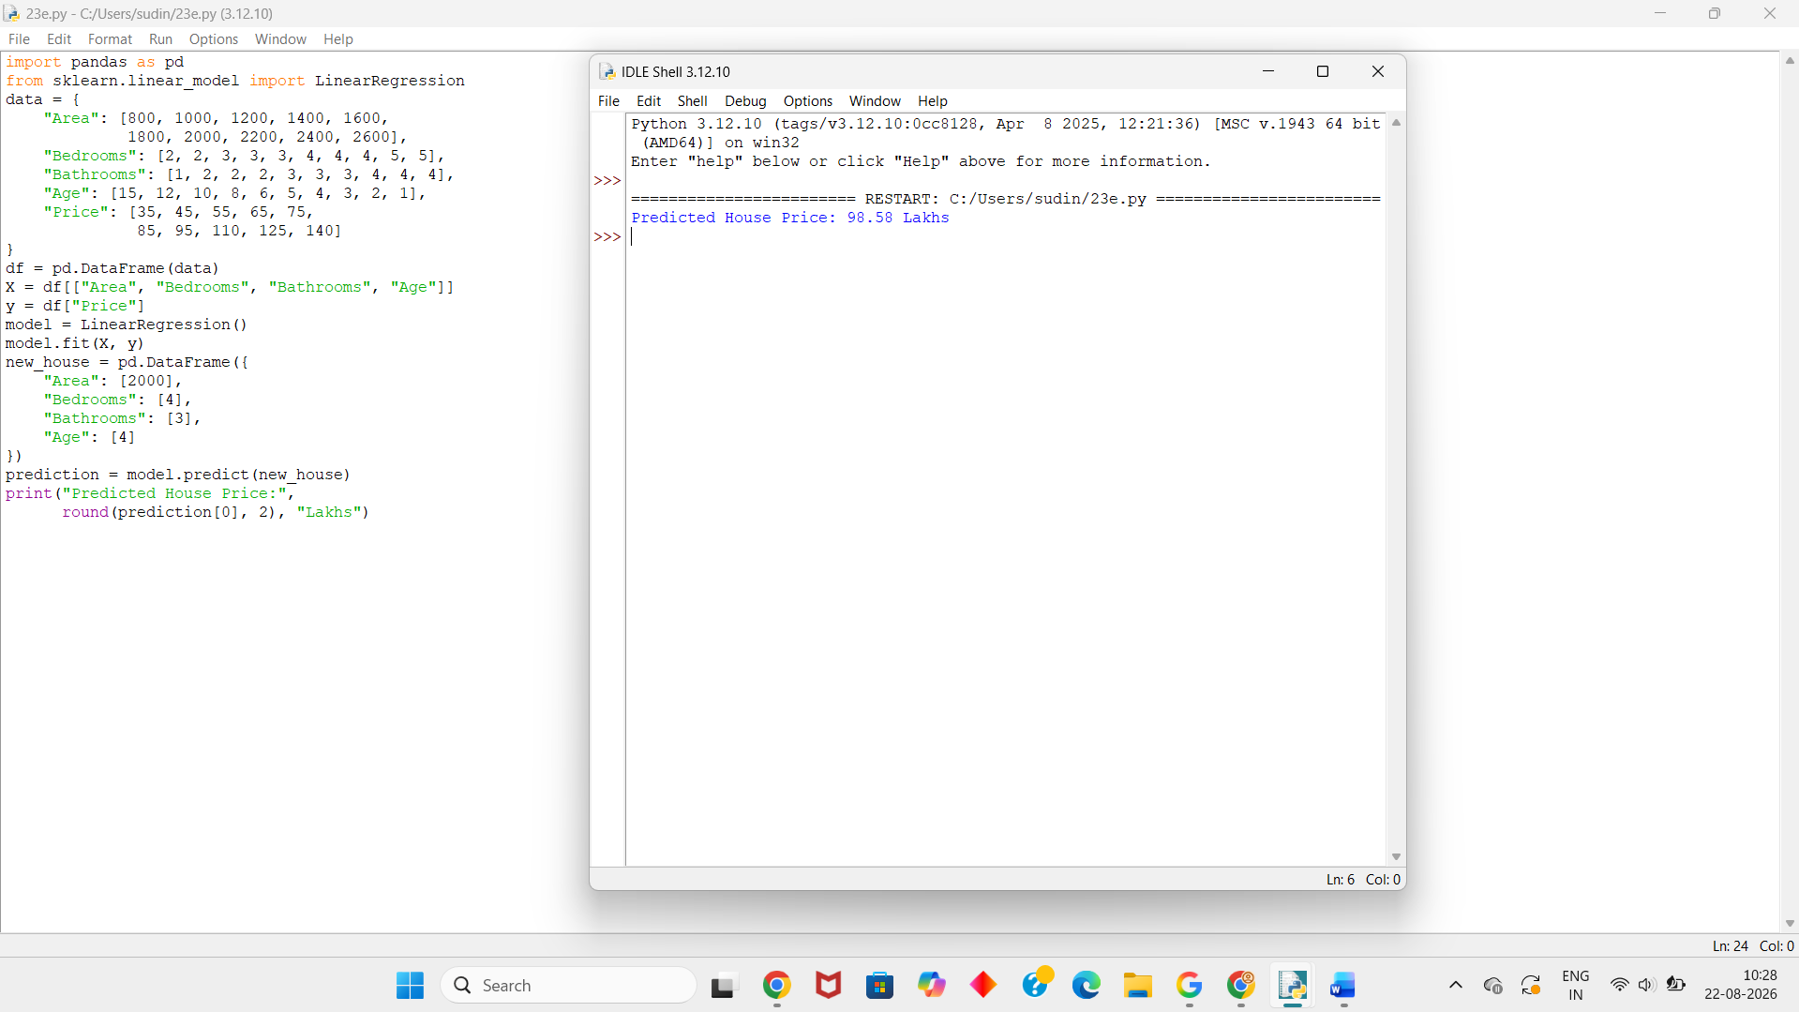
Dataset 2 – House Price Prediction
Area (sq.ft) | Bedrooms | Bathrooms | Age (Years) | Price (Lakhs)
700 | 1 | 1 | 20 | 25
900 | 2 | 1 | 18 | 32
1100 | 2 | 2 | 15 | 42
1300 | 3 | 2 | 12 | 52
1500 | 3 | 2 | 10 | 62
1700 | 3 | 3 | 8 | 72
1900 | 4 | 3 | 6 | 84
2100 | 4 | 3 | 4 | 96
2300 | 4 | 4 | 3 | 108
2500 | 5 | 4 | 2 | 122
Python Code:
import pandas as pd
from sklearn.linear_model import LinearRegression
data = {
"Area": [700, 900, 1100, 1300, 1500,
1700, 1900, 2100, 2300, 2500],
"Bedrooms": [1, 2, 2, 3, 3, 3, 4, 4, 4, 5],
"Bathrooms": [1, 1, 2, 2, 2, 3, 3, 3, 4, 4],
"Age": [20, 18, 15, 12, 10, 8, 6, 4, 3, 2],
"Price": [25, 32, 42, 52, 62,
72, 84, 96, 108, 122]
}
df = pd.DataFrame(data)
X = df[["Area", "Bedrooms", "Bathrooms", "Age"]]
y = df["Price"]
model = LinearRegression()
model.fit(X, y)
new_house = pd.DataFrame({
"Area": [1800],
"Bedrooms": [3],
"Bathrooms": [3],
"Age": [7]
})
prediction = model.predict(new_house)
print("Predicted House Price:",
round(prediction[0], 2), "Lakhs")
Output:

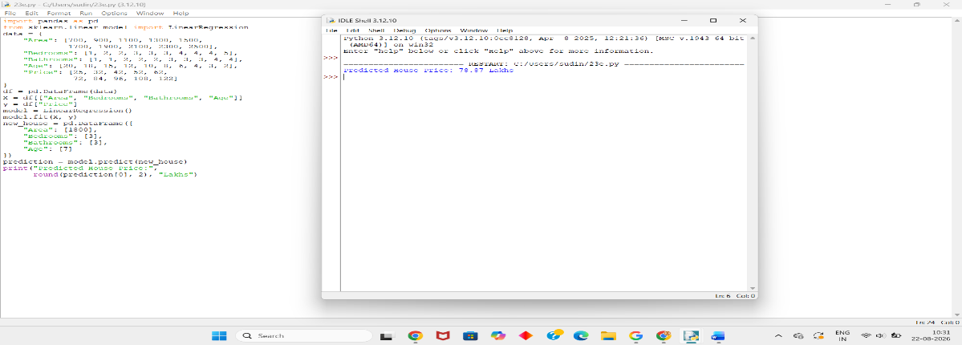

Dataset 3 – House Price Prediction
Area (sq.ft) | Bedrooms | Bathrooms | Age (Years) | Price (Lakhs)
600 | 1 | 1 | 25 | 20
800 | 2 | 1 | 20 | 28
1000 | 2 | 2 | 17 | 38
1200 | 2 | 2 | 14 | 46
1400 | 3 | 2 | 12 | 56
1600 | 3 | 3 | 9 | 68
1800 | 3 | 3 | 7 | 78
2000 | 4 | 3 | 5 | 90
2200 | 4 | 4 | 3 | 105
2500 | 5 | 4 | 2 | 125
Python Code:
import pandas as pd
from sklearn.linear_model import LinearRegression
data = {
"Area": [600, 800, 1000, 1200, 1400,
1600, 1800, 2000, 2200, 2500],
"Bedrooms": [1, 2, 2, 2, 3, 3, 3, 4, 4, 5],
"Bathrooms": [1, 1, 2, 2, 2, 3, 3, 3, 4, 4],
"Age": [25, 20, 17, 14, 12, 9, 7, 5, 3, 2],
"Price": [20, 28, 38, 46, 56,
68, 78, 90, 105, 125]
}
df = pd.DataFrame(data)
X = df[["Area", "Bedrooms", "Bathrooms", "Age"]]
y = df["Price"]
model = LinearRegression()
model.fit(X, y)
new_house = pd.DataFrame({
"Area": [1600],
"Bedrooms": [3],
"Bathrooms": [3],
"Age": [8]
})
prediction = model.predict(new_house)
print("Predicted House Price:",
round(prediction[0], 2), "Lakhs")

Output:
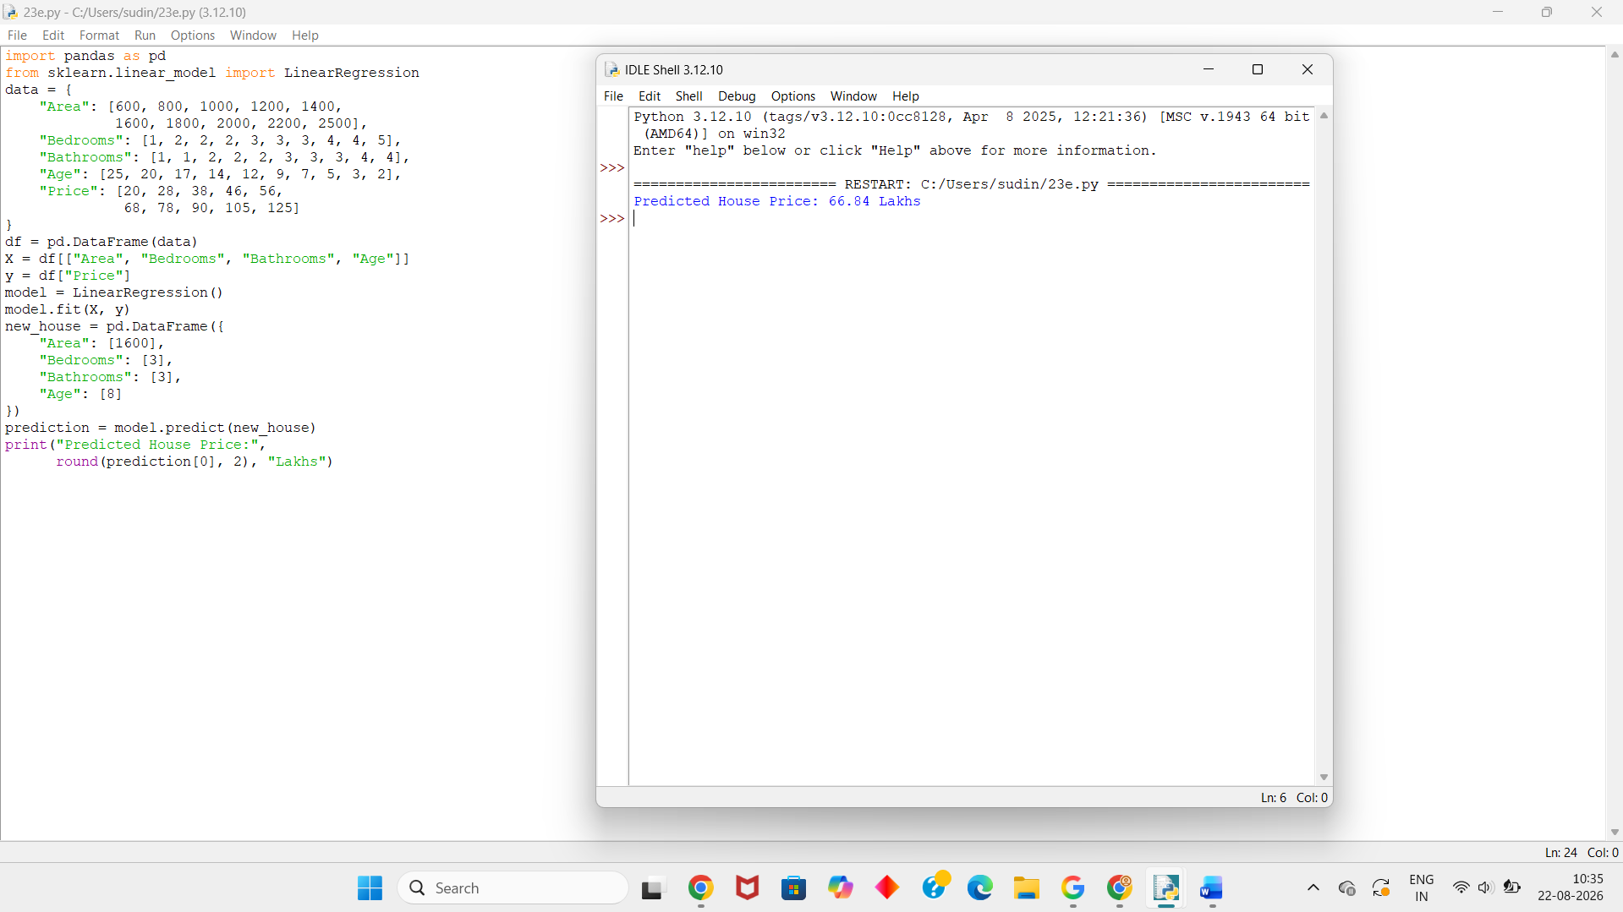
Dataset 4 – House Price Prediction
Area (sq.ft) | Bedrooms | Bathrooms | Age (Years) | Price (Lakhs)
750 | 1 | 1 | 18 | 27
950 | 2 | 1 | 16 | 36
1150 | 2 | 2 | 13 | 46
1350 | 3 | 2 | 11 | 57
1550 | 3 | 2 | 9 | 67
1750 | 3 | 3 | 7 | 78
1950 | 4 | 3 | 5 | 90
2150 | 4 | 3 | 4 | 103
2350 | 4 | 4 | 2 | 118
2550 | 5 | 4 | 1 | 135
Python Code:
import pandas as pd
from sklearn.linear_model import LinearRegression
data = {
"Area": [750, 950, 1150, 1350, 1550,
1750, 1950, 2150, 2350, 2550],
"Bedrooms": [1, 2, 2, 3, 3, 3, 4, 4, 4, 5],
"Bathrooms": [1, 1, 2, 2, 2, 3, 3, 3, 4, 4],
"Age": [18, 16, 13, 11, 9, 7, 5, 4, 2, 1],
"Price": [27, 36, 46, 57, 67,
78, 90, 103, 118, 135]
}
df = pd.DataFrame(data)
X = df[["Area", "Bedrooms", "Bathrooms", "Age"]]
y = df["Price"]
model = LinearRegression()
model.fit(X, y)
new_house = pd.DataFrame({
"Area": [2000],
"Bedrooms": [4],
"Bathrooms": [3],
"Age": [5]
})
prediction = model.predict(new_house)
print("Predicted House Price:",
round(prediction[0], 2), "Lakhs")
Output:
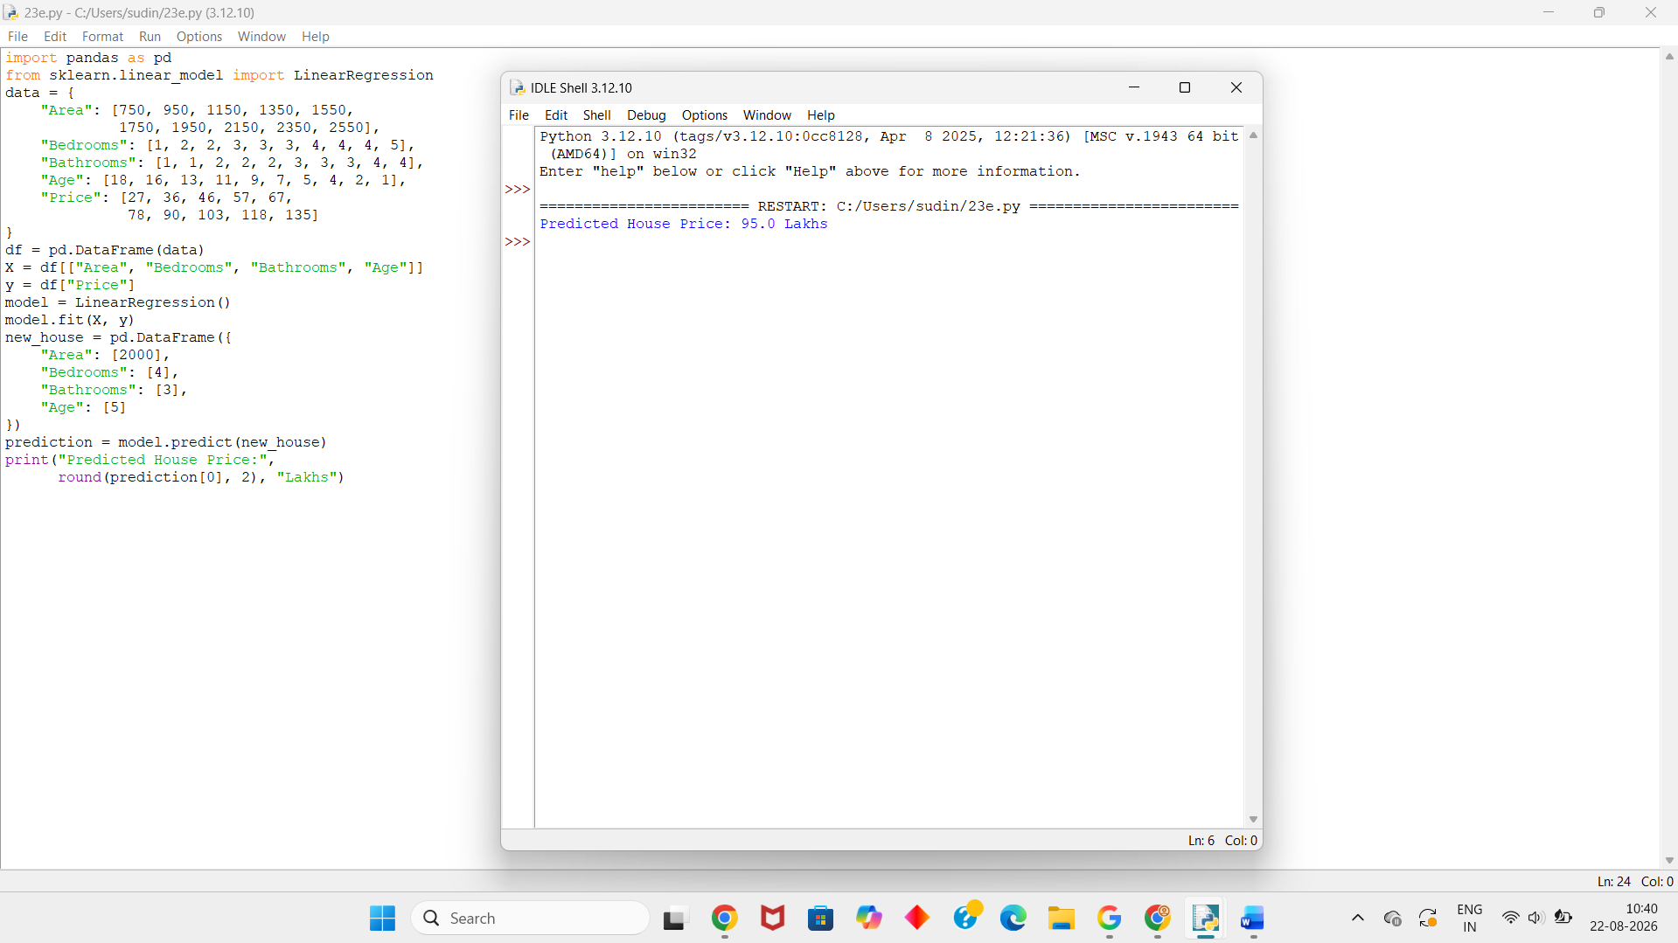
Dataset 5 – House Price Prediction
Area (sq.ft) | Bedrooms | Bathrooms | Age (Years) | Price (Lakhs)
650 | 1 | 1 | 22 | 22
850 | 2 | 1 | 19 | 31
1050 | 2 | 2 | 16 | 40
1250 | 3 | 2 | 13 | 51
1450 | 3 | 2 | 11 | 61
1650 | 3 | 3 | 8 | 73
1850 | 4 | 3 | 6 | 85
2050 | 4 | 3 | 4 | 98
2250 | 4 | 4 | 2 | 112
2450 | 5 | 4 | 1 | 128
Python Code:
import pandas as pd
from sklearn.linear_model import LinearRegression
data = {
"Area": [650, 850, 1050, 1250, 1450,
1650, 1850, 2050, 2250, 2450],
"Bedrooms": [1, 2, 2, 3, 3, 3, 4, 4, 4, 5],
"Bathrooms": [1, 1, 2, 2, 2, 3, 3, 3, 4, 4],
"Age": [22, 19, 16, 13, 11, 8, 6, 4, 2, 1],
"Price": [22, 31, 40, 51, 61,
73, 85, 98, 112, 128]
}
df = pd.DataFrame(data)
X = df[["Area", "Bedrooms", "Bathrooms", "Age"]]
y = df["Price"]
model = LinearRegression()
model.fit(X, y)
new_house = pd.DataFrame({
"Area": [1800],
"Bedrooms": [4],
"Bathrooms": [3],
"Age": [6]
})
prediction = model.predict(new_house)
print("Predicted House Price:",
round(prediction[0], 2), "Lakhs")

Output:
